**How do I allow users to upload only certain file types to my Amazon S3 bucket?**

1. Create a user.

2. add the necessary permission to the user.

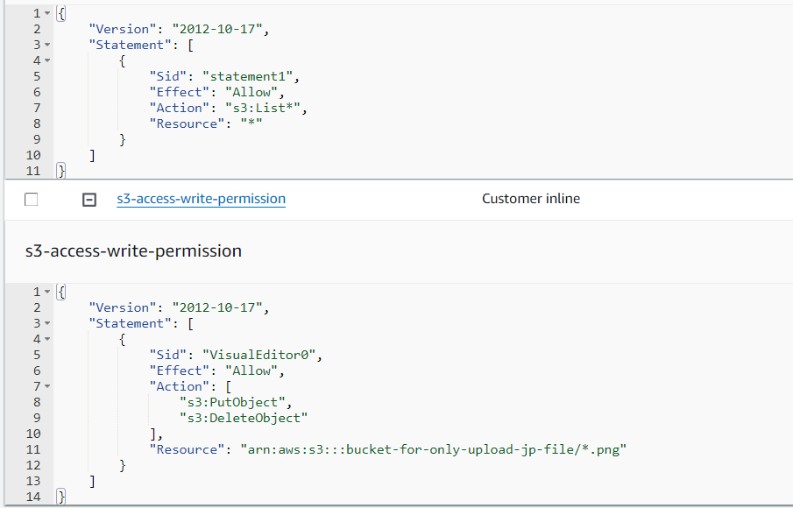

3. try to upload the jpg file.

4. try to upload the png file.

**Conclusion**:

Done with the help of <https://repost.aws/knowledge-center/s3-allow-certain-file-types>